Chapter 2, Problem 47.

Find the equivalent resistance R_{ab} in the circuit of Fig. 2.111.
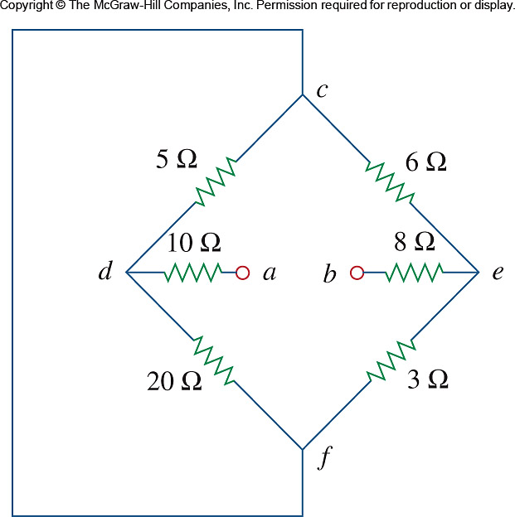

Figure 2.111
For Prob. 2.47.

